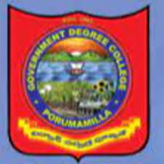

GOVERNMENT DEGREE COLLEGE
PORUMAMILLA
HISTORY DEPARTMENT
POS

GOVERNMENT DEGREE COLLEGE, PORUMAMILLA.

DEPARTMENT OF HISTORY
(POS )

With the goal of enabling students to gain a comprehensive knowledge and comparative Knowledge in History, the Department of History Government degree College, Porumamilla offers three- year undergraduate programs (B.A., H.E.P. & Honors) that span six semesters. The following skills will be acquired by students upon successfully completing the B.A. History Degree Program.

POs 1 | Students will have the ability to apply historical methods to evaluate critically the past and how historians and others have interpreted it.
POs 2 | Students will be able to acquire basic historical research skills, including the effective  use of libraries, archives and data bases.
POs 3 | Students will be able to organize and express their thoughts clearly and coherently  Both in writing and orally.
POs 4 | Students will be able to demonstrate broad knowledge of historical events and periods  and their significance
POs 5 | Students will be able to recognize how different individuals, groups, organizations,  societies, cultures, countries and nations have affected history. History gave the students wisdom and foresight for the future.

